- A)
- Xn = 1.0 h = 0.1
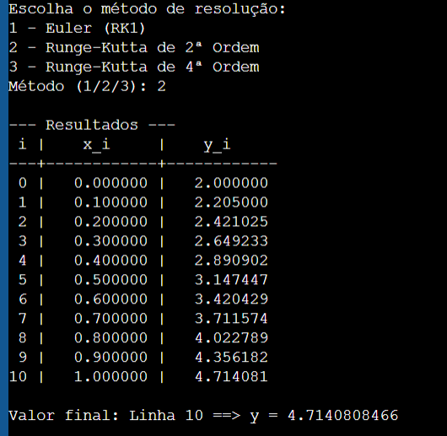

- Xn = 1.0 h = 0.01


- Xn = 0.5 h = 0.1
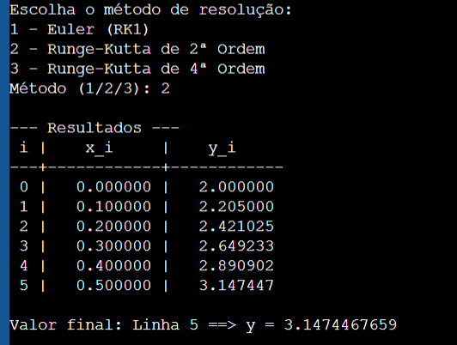
- Xn = 0.5 h = 0.01


B)
- Xn = 1.0 h = 0.1
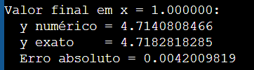

- Xn = 1.0 h = 0.01
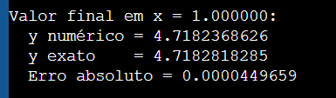

- Xn = 0.5 h = 0.1
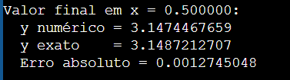

- Xn = 0.5 h = 0.01
